Conference Hotels
We look forward to your visit to Columbia!
For your convenience, listed below are hotels where we are holding room blocks.

 | Charge | N rooms | Deadline for
 | per night ($) | blocked | block rate | Code
Clarion Hotel Downtown | $92.00+tax | 25 | Oct.1 | GEO
Courtyard by Marriott | $95 00+tax | 25 | Sept.14 | GEO
Inn at USC | $100.00+tax | 25 | Sept.14 | GEO
Rodeway Inn | $60.00+tax | 25 | Sept.10 | GEO or Geomorphology
Details below

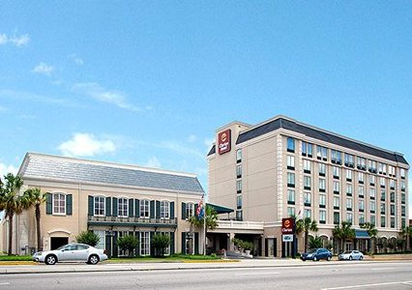

The Clarion Town House
1615 Gervais Street, Columbia, SC 29201
(803) 771-8711; (803) 252-9347
RATE: $92.00 per night plus tax.
To qualify for the special conference rate, please make your reservation by calling 1-800-277-8711 by October 1, 2010 and reference the following code GEO to ensure you will receive the discounted rate when making your reservation.
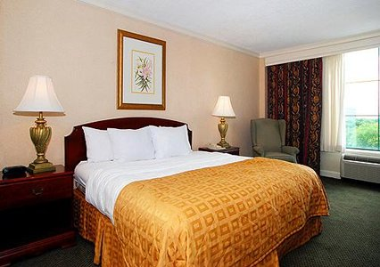
163 luxurious tower and courtyard guestrooms, including suites. Relax in our spacious rooms that were designed with comfort in mind. Every guestroom is oversized and has a work desk, phone with data port, coffee maker, and elegant furnishings. Choose from rooms with a king - size bed or two queen-size beds. Your weekday newspaper is complimentary. The hotel also offers non-smoking and ADA approved rooms.
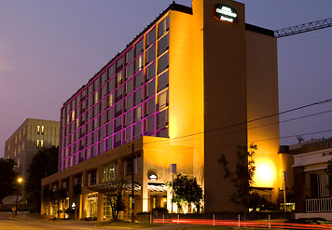
The Courtyard by Marriott
630 Assembly St, Columbia, SC 29201
(803) 799-7800; (803) 744-6902
RATE: $95.00 per night plus tax (includes parking)
To qualify for the special conference rate, please make your reservation by calling (800) 593-6465 by September 14, 2010 and reference the following code GEO to ensure you will receive the discounted rate when making your reservation.
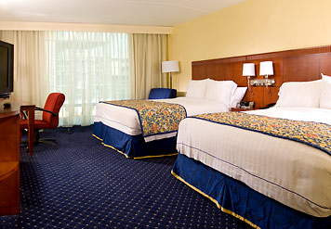
Located in downtown Columbia, the Courtyard Marriott is close to USC, the Colonial Life Arena, the Coliseum, the School of Music, the Koger Center for the Arts, the Vistas shops and restaurants and Five Points. The hotel offers complimentary WIFI throughout hotel, and a complimentary shuttle from Columbia Metropolitan Airport. Other complimentary services include coffee in lobby, Grab-n-Go Breakfast and toll-free phone calls.
Standard Check InTime: 4:00 pm Check Out: 11:00 am
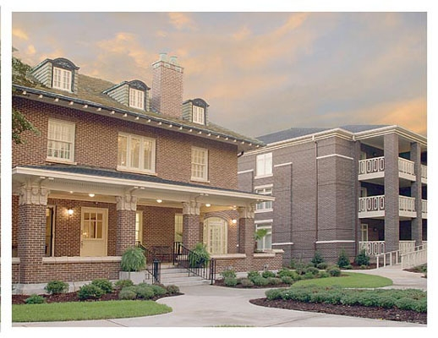
Inn at USC
1619 Pendleton Street
Columbia, SC 29201
(803) 779-7779 phone
(803) 779-2197 fax
RATE: $100.00 per night plus tax includes breakfast
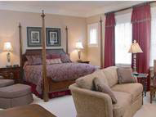
To qualify for the special conference rate, please call the Inn at (803) 779-7779 make your reservation by September 14, 2010 and reference the code GEO to ensure you will receive the discounted rate when making your reservation.
The Inn at USC, which opened in late 2005, is the new leader in quality accommodations. This state-of-the-art hotel was built around an historic family home and was designed to complement the historic character of the two structures remaining on the 1600 block of Pendleton Street. The original family home, built in 1912, was restored and incorporated into the Inn.
A front plaza with a water feature leads to the lobby and to gardens typical of the University neighborhood. The balconies and porches of the Inn give it the feel of the residential area surrounding it. The first floor consists of the lobby, offices, and a library. The second floor features three luxury suites. The Inn features 117 guest rooms, including 31 two-room suites. The third floor is designed as a concierge level with a concierge lounge. Other amenities include an exercise room, meeting and seminar rooms, a catering kitchen, and a dining area for breakfast for guests, and catered luncheon service when needed.
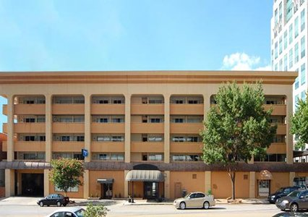

The Rodeway Inn
1301 Main Street, Columbia, SC, US, 29201
Phone: (803) 779-7790; fax: (803) 779-7856 fax
RATE: $60 per night plus tax
To qualify for the special conference rate, please call the Inn at (803) 779-7790 to make your reservation by September 10, 2010 and reference the code GEO to ensure you will receive the discounted rate when making your reservation.

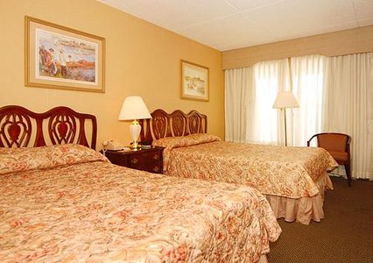
The Rodeway Inn® hotel is conveniently located in historic downtown Columbia, less than one mile from the University of South Carolina and the Columbia Museum of Art. This Columbia hotel is minutes from the Colonial Center multi-purpose arena, the Riverbanks Zoo and Garden and Fort Jackson United States Army training center. The Columbia Metropolitan Airport is 10 miles away.
Hotel amenities and features include:
- Free continental breakfast
- Free wireless high-speed Internet access in all rooms
- Free local calls
All guest rooms have coffee makers, desks, hair dryers, irons, ironing boards and cable television. Some rooms come equipped with microwaves and refrigerators. Non-smoking rooms are available.

